**COMPUTER SCIENCE VERSUS A VIRUS**

Gökay Arıdıcı

Ege University, Department of Computer Engineering 35100 Bornova-İzmir

ggokayaridici@gmail.com

Date: 07/06/2020

Abstract. Since its appearance in China in December 2019 COVID-19 took over the world,spread over the world and killed thousands. Its impact on human life affected us and also our computer life. In this article I will firstly present introduction of the article and its statemens. This article is based on the impact of the COVID-19 in computer science. The subtitles will be focused on communication and network technologies, data science, artifical intelligence, data security,data security, piracy, cyber attacks and computer ethics. After that I will present my own analysis and discussion of the topic. There will be a conclusion part and lastly references.

**Keywords:** COVID-19, communication, data , AI , cyber attacks , computer ethics

1. Introduction

Computer science is important because computers are. Computers are important because we use them and we need them. In 21st century, we use computers in every subject. This hasn’t changed since COVID-19 and now COVID-19 is one of the subjects that computers work on too. It affected us the way we use computers. Computer science is also affected because of the computers and its sujects are changed to behave alongside to COVID-19.

**2. Literature Work and Statement**

In this article I will be focusing on COVID-19 and its impact on computer science. Computer science is a very wide area. My focus will be on 5 different topic.

1. Communication and Network Technologies
2. Data Science
3. Artificial Intelligence
4. Data Security, Piracy and Cyber Attacks
5. Computer Ethics

I will talk about 5G in Topic 1 for example and big data in topic 2. Data is important for COVID-19 because computers need something to work on. Not just any computer program can work on this data, we need artifical intelligence(AI) for this matter. In this cyber life, we have to secure our information because there will be people that want to steal it. There are lots of cyber attacks around COVID-19.

**3. The Impact of Covid-19 in Computer Science**

Computer science is more important than it has ever been before at the moment. We are in the middle of a crisis, we need help and computers can provide this help. Starting with communication, we will look at data science, AI, data security and computer ethics in this part.

**3.1 Communication and Network Technologies**

**Although the coronavirus negatively affected many sectors, the communication activities of brands continued without slowing down[1]. There has been a 28% increase in digital PR activities of brands after the coronavirus. The coronavirus pandemic was the subject of 62% of the communication activities. In March and April, when the coronavirus affected business life, 30% of the companies that continued communication were companies from the IT sector, %15 were education, %15 were media and %12 were health companies.Also with the cessation of physical contact, the real estate sector started to take steps towards digitalization. The communication activities included topics such as prepation for the increase in demand after the pandemic, innovations to protect social isolation and online training.**

Microsoft’s analysis shows that**[2]**: There is increasing author participation in both CS and AI conferences from the COVID-19 impacted regions in the past ten years, from about 6% to over 20% in 2019.The disease could impact one-fifth of conference attendees in both AI and CS (21.3%).May to early September is the period most CS conferences occur, controlling COVID-19 by May will help to reduce the impact in CS research to a minimum.

One of the most interesting things about COVID-19 is 5G. 5G is the 5th generation mobile network. It is a new global wireless standard after 1G, 2G, 3G, and 4G networks. 5G enables a new kind of network that is designed to connect virtually everyone and everything together including machines, objects, and devices**[3]**. 5G will be mostly used for enhanced mobile broadband , mission-critical communications and massive IoT.

There wasn’t a problem about 5G before COVID-19. Because of the reason they were both started get popular around the world, some people thought 5G is the culprit. Theorists claim coronavirus is just a cover up of the dangers of 5G**[4]**. People even burned down some 5G towers in England. Network provider EE told Euronews in an email that its engineers were currently assessing the cause of a blaze at a mast in Birmingham that had caused "significant damage".

The coronavirus caused a huge strain on internet traffic, with an increase of %60 and %50 in broadband usage of BT Group and Vodafone respectively.In the meantime, Netflix, Disney+, Google, Amazon and Youtube considered the notion to reduce their video quality to prevent the overloard. Meanwhile, Sony started slowing down PlayStation game downloads in Europe and the United States to maintain the traffic level**[5][6]**.

**3.2 Data Science**

In order to prevent COVID-19, make it harmless and lower the death rate, we have keep COVID-19 related data. Science this is a global pandemic, this data is so big that we have to use big data.

In the context of COVID-19, big data refers to the patient care data such as physician notes, X-Ray reports, case history, list of doctors and nurses, and information of outbreak areas.**[7]** Big data potentially provide a number of promising solutions to help combat COVID-19 epidemic. By combining with AI analytics, big data helps us to understand the COVID-19 in terms of outbreak tracking, virus structure, disease treatment, and vaccine manufacturing.

Fig. 4 shows how big data and its applications fight COVID-19 pandemic.

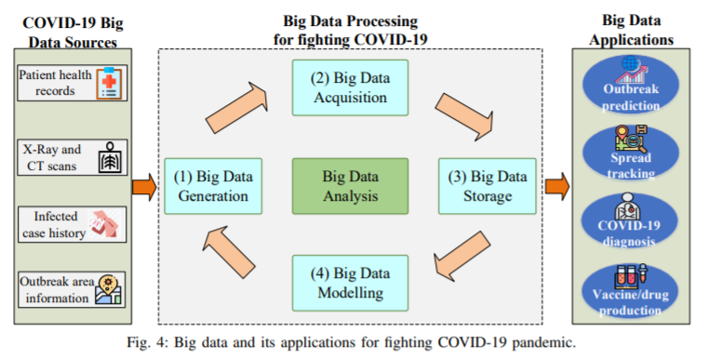

**3.3 Artificial Intelligence**

The question of how computers can contribute to controlling the COVID-19 pandemic is being posed to experts in artificial intelligence (AI) all over the world**[8]**. AI tools can help in many different ways. They are being used to predict the spread of the coronavirus, map its genetic evolution as it transmits from human to human, speed up diagnosis, and in the development of potential treatments, while also helping policymakers cope with related issues, such as the impact on transport, food supplies and travel.

AI can also be used to help identify individuals who might be unknowingly infected with COVID-19. Chinese tech company Baidu says its new AI-enabled infrared sensor system can monitor the temperature of people in the proximity and quickly determine whether they may have a fever, one of the symptoms of the coronavirus.

Another directive for COVID-19 detection is to use AI techniques for medical image processing, which recently appeared in many preprints on coronaviruses. Figure 3 shows how this process works.

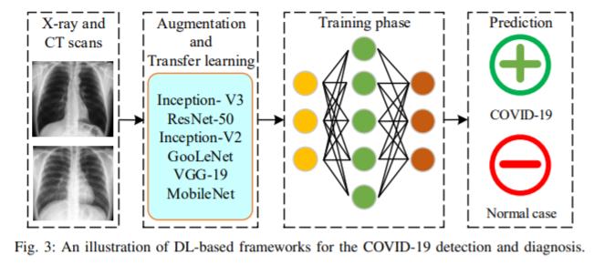

Based on the technique that used, prediction can be up to 99%.

AI and big data have found in a lot of applications in various fields, e.g., AI in computer science, AI in banking, AI in agriculture, and AI in healthcare. These technologies are expected and may play important roles in the global battle against the COVID-19 pandemic.

**3.4 Data Security, Privacy and Cyber Attacks**

There has been a spike in cyber attacks during the coronavirus pandemic, targeting government and medical organisations at the forefront of the response to COVID-19**[9]**. Most of the incidents were phishing campaigns that took the form of either ransomware attacks – which if activated encrypt IT systems and demand a payment for bringing them back online – or ‘infostealer’ malware designed to gather information. It isn’t a surprise to see cybercriminals “taking advantage of the ongoing COVID-19 pandemic crisis and using COVID-19 as a lure to entice victims to click on malicious attachments and infect their systems.” In response to news of the attacks, Microsoft has started offering its AccountGuard threat notification service – usually used by political groups – at no cost to healthcare organisations and human rights and humanitarian groups.

Another COVID-19 case has been reported by Microsoft Security Intelligence Team **[10]**. The latest version of Trickbot/Qakbot/Qbot malware has been spread in numerous phishing emails offering free COVID-19 testing. Victims were asked to fill out an attached form, which turned out to be a fake document embedded with a malicious script. To avoid revealing its payload in malware sandboxes, the script would not start downloading its payload until after some time had passed. The lure document uses a standard gimmick to trick users into clicking ‘Enable Content’ which allows the execution of the malicious VBA script that is embedded.

**3.5 Computer Ethics**

During the COVID-19 pandemic, with adolescents likely to use digital platforms even more for personal or educational purposes, there could be concurrent increase in cyberbullying, an expert warned**[11]**. “When smartphones and social media became ubiquitous for students, cyberbullying rates went up,” Sameer Hinduja, PhD, professor of criminology and criminal justice at Florida Atlantic University and co-director of the Cyberbullying Research Center, said in a news release. “This makes sense, of course, because there was now an almost limitless number of potential targets and aggressors,” he continued. “During this unprecedented time when [children] are all stuck at home, those same students will be using apps even more than they already do with them being forced to use online platforms for learning, regardless of their level of comfort or proficiency.” “Remind your child that most bullies have low self-esteem, and they bully others to try and feel better about themselves,” Dr. Christopher Min, a CHOC Children’s psychologist**[12]**.

Ten Commandments of Computer Ethics says thou shall not Thou shalt not use a computer to harm other people. People are harmful even more these days and we have to overcome this.

**4. Discussion**

Bad events in history always taught humanity some lessons. We learned, we adapted and overcame things based on these lessons. Like every other lesson, COVID-19 taught us some lessons too. We learned people does not know enough about 5G science they burned down towers. We learned to use AI better since it helps to fight COVID-19. We learned even in the middle of a global pandemic; front-health workers get bullied. Hackers tries to steal information as usual. It’s not anormal for people to click something like “FREE COVID-19 TESTING” while people all around the world are dying. Apart from medical organizations, cyber-bullying is a very important problem. COVID-19 is not the only problem at his moment and it will not be.

5. Conclusion

In the time of COVID-19, computer science got more important than it was never before. It pushed the limits of our internet infrastructure and will be push since the day humanity finds the vaccine of the virus. We need better internet hardware and software. We learned how to use AI better in healthcare so we can detect COVID-19 infected people faster and more accurate. We may use AI in healthcare more than ever before in the future. We also learned using big data better for AI. The data is getting bigger every day and we have to work hard in order to continue using it. There will be also a lot of cyber bullying and cyber attacks in the future. We can not prevent all of them but we can try.

References

[1] B2PRESS, <https://b2press.com/en-US/newsroom/656/coronavirus-did-not-affect-the-communication-activities-of-companies> (Last accessed: 04 July 2020)

[2] Microsoft, https://www.microsoft.com/en-us/research/project/academic/articles/impact-of-covid-19-on-computer-science-research-community/ (Last accessed: 04 July 2020)

[3] Qualcomm, <https://www.qualcomm.com/invention/5g/what-is-5g>

(Last accessed: 07 July 2020)

[4] Euro news, https://www.euronews.com/2020/04/04/is-coronavirus-a-cover-up-for-deadly-effects-of-5g-technology-euronews-answers (Last accessed: 07 July 2020)

[5] CNBC , <https://www.cnbc.com/2020/03/27/coronavirus-can-the-internet-handle-unprecedented-surge-in-traffic.html> (Last accessed: 07 July 2020)

[6] Techradar , <https://www.techradar.com/news/sony-slows-ps4-game-download-speeds-in-the-us-and-europe> (Last accessed: 07 July 2020)

[7] Quoc-Viet Pham, Dinh C. Nguyen, Thien Huynh-The, won-Joo Hwang, Pubudu N Pathirana, “Artificial Intelligence (AI) and Big Data for Coronavirus (COVID-19) Pandemic: A Survey on the State-of-the-Arts” , <https://www.researchgate.net>, [10.13140/RG.2.2.23518.38727](https://www.researchgate.net/deref/http%3A%2F%2Fdx.doi.org%2F10.13140%2FRG.2.2.23518.38727?_sg%5B0%5D=AJVDGDIxCaMhlnVJXNlAz7iyTAo-TMpG6dw5RI3ieNJ2ac372GgxWZF_GPoJ1QTs83TWu6vkZNRzqAC8E8L5HbjzRA.dL2fcGmzzhpAT7FBl9PPAIx1go90Fq96el4TZU4aoIfmdp8ks6GVQovG9kW7nmQy2gXjfRIRxC9pqPXqHouCyA) , April 2020

[5] Science Business, <https://sciencebusiness.net/covid-19/news/computer-science-versus-covid-19> (Last accessed: 07 July 2020)

[9] pharmaphorum, <https://pharmaphorum.com/news/covid-19-themed-cyberattacks-hit-healthcare-bodies/> (Last accessed: 07 July 2020)

[10] Acronis , <https://www.acronis.com/en-us/blog/posts/covid-19-themed-cyberattacks-taking-hold> (Last accessed: 07 July 2020)

[11] Healio , <https://www.healio.com/news/pediatrics/20200330/cyberbullying-may-increase-during-covid19-pandemic-expert-says> (Last accessed: 07 July 2020)

[12] CHOC Children’s, https://blog.chocchildrens.org/cyberbullying-and-covid-19/

(Last accessed: 07 July 2020)